PROJECT PROGRESS REPORT
Deliverable — Consolidated Record of Work Completed to Date
Intelligent Sensor System for Early Prediction of Sepsis
in Neonates and High-Risk Adults
A SERS Nanosensor Platform for Direct Bacterial Biomarker Detection

Prepared by | Sukesh P
Programme / Roll No. | Masters in Medical Technologies | M24IM1007
Institution | IIT Jodhpur and AIIMS Jodhpur Joint Programme
Project Proposal | Sepsis Detection using SERS Nanosensor — Proposal 2025
Evidence basis | Full project archive: raw and processed Raman data, DFT outputs,  lab notebooks, presentations, SOPs and prior progress reports
Report date | 21 August 2026

This report distinguishes work that is completed and validated, work that is preliminary or ongoing, and work that remains proposed for future phases.

1. Introduction
Sepsis is a life-threatening condition associated with a dysregulated host response to infection and is a major cause of mortality, particularly among neonates and critically ill or high-risk adults. Globally it is estimated to affect around 49 million people and cause approximately 11 million deaths per year — close to 20% of all global deaths. The project proposal underlying this work, “Intelligent Sensor System for Early Prediction of Sepsis in Neonates and High-Risk Adults” (IIT Jodhpur – AIIMS Jodhpur joint programme), set out to develop a rapid, nanotechnology-enabled sensing platform capable of detecting bacterial components associated with sepsis directly, rather than relying exclusively on indirect host-response biomarkers such as CRP, PCT or IL-6.
The proposed system combines Surface-Enhanced Raman Spectroscopy (SERS), nanostructured sensing substrates, Raman spectral analysis and artificial intelligence to establish a rapid pathway toward pathogen-associated biomarker detection. The long-term goal is an intelligent, point-of-care diagnostic platform suitable for clinical environments such as intensive care units and neonatal wards.
This report consolidates all work carried out to date against the five objectives, five methodological phases and four deliverables defined in the original proposal. It was compiled by reviewing the full project archive — raw and processed Raman data (920 CSV and 462 XLSX files), DFT computational outputs, 40 analysis scripts and 24 notebooks, 195+ figures, and 52 DOCX / 78 PDF / 15 PPTX supporting documents, including the previously submitted M24IM1007 project report and the prior consolidated status report dated 3 August 2026. Where different working files in the archive report slightly different numbers for the same experiment (reflecting iterative re-analysis), this report uses the most recent, most complete analysis branch and flags the discrepancy.
The work reported here primarily addresses the initial stage of the proposed development pathway: biomarker characterisation, Raman spectral reference generation, SERS substrate fabrication and validation, and investigation of the detectability of selected bacterial biomarkers on the fabricated substrate.

2. Project Objectives (as defined in the proposal)
The project proposal defines one overarching goal — an AI-powered intelligent sensor system for real-time, rapid pathogen detection in neonates and high-risk adults — realised through five specific objectives:
# | Objective | Definition (from proposal)
1 | Biomarker Discovery | Identify bacterial biomarkers (e.g. LPS, peptidoglycan) specific to Gram-positive and Gram-negative sepsis-causing bacteria, using Raman spectroscopy on pure, commercially sourced bacterial components as reference standards.
2 | SERS-Based Sensing Technology | Develop a SERS-enabled nanosensor chip optimised for detection of the discovered biomarkers.
3 | AI-Integrated Raman Analysis | Develop AI / neural-network algorithms for automated interpretation of Raman spectral signatures, improving specificity and accuracy.
4 | Clinical Validation | Evaluate the SERS-based sensor on clinical samples from neonates and high-risk adults to assess accuracy, sensitivity and specificity.
5 | Prototype Development | Design and fabricate a point-of-care (PoC) device for real-time sepsis detection in ICU / neonatal-ward settings.

The work completed to date is concentrated on Objectives 1 and 2, with the experimental and computational datasets generated also forming the basis needed for Objective 3.

3. Alignment of the Present Work with the Proposed Project
The current phase of work can be organised into ten major activity streams, each mapped to specific evidence in the project archive:
- Computational (DFT) investigation of selected bacterial biomarkers and structural fragments.
- Experimental Raman characterisation of pure biomarker materials (NAM, LTA) and a reference molecule (Rhodamine B / R6G).
- Comparison between theoretical (DFT) and experimental Raman spectra, with quantitative peak-matching statistics.
- Investigation of LPS-related molecular fragments (KDO, heptose, glucosamine, myristic acid, phosphoric acid) via component-based modelling and non-negative least-squares (NNLS) spectral fitting.
- Investigation of lipoteichoic acid (LTA) as a Gram-positive structural target, including a 12-spot spatial-reproducibility study and a 136-spectrum acquisition-parameter study.
- Fabrication of an Ag-coated nanostructured/porous silicon SERS substrate via HF etching and AgNO₃-based galvanic silver deposition.
- Validation of the SERS substrate using Rhodamine 6G (R6G) as a standard positive-control probe.
- Preliminary experimental investigation of NAM detection using the fabricated SERS substrate.
- Systematic Raman data preprocessing (dark subtraction, ALS baseline correction, Savitzky–Golay smoothing, normalisation), peak analysis and spectral-quality scoring (SNR).
- Identification and documentation of the limitations currently affecting direct SERS detection of NAM, and definition of the corrective next steps.

This work establishes the initial Raman spectral reference library and the first-generation SERS substrate called for in Objectives 1 and 2 of the proposal.

4. Biomarker Selection and Characterisation

4.1 Rationale
Rather than starting directly with complex clinical blood matrices, the project adopted a biomarker-first strategy using three bacterial structural targets that give direct, interpretable evidence of bacterial presence and Gram class:
Biomarker | Biological Origin / Significance | Intended Diagnostic Role
NAM (N-acetylmuramic acid) | Structural sugar component of bacterial peptidoglycan, present across essentially all bacterial cell walls. | General bacterial indicator — first, most detailed reference target.
LTA (lipoteichoic acid) | Amphiphilic glycerol-phosphate polymer anchored in the Gram-positive cell wall. | Gram-positive indicator.
LPS (lipopolysaccharide) | Glycolipid of the Gram-negative outer membrane (Lipid A + core oligosaccharide + O-antigen). | Gram-negative indicator.

This selection gives interpretable coverage of both Gram-negative and Gram-positive targets called for in Objective 1, while keeping each experimental system chemically tractable for both Raman acquisition and DFT modelling.

5. Computational Raman Investigation (DFT)
Density Functional Theory (DFT) calculations were used to generate theoretical Raman signatures for each biomarker, supporting peak assignment where experimental bands from complex bacterial biomolecules would otherwise be ambiguous. The general workflow was: build/obtain molecular structure → geometry optimisation → frequency calculation with Raman activity → extraction of positive vibrational frequencies → frequency scaling → Gaussian/Lorentzian broadening → comparison with the experimental spectrum.

5.1 NAM — whole-molecule modelling
NAM is small enough for full-molecule DFT. Geometry optimisation and Raman-active frequency calculation were performed in Gaussian; the analysis was later standardised on a 0.96 empirical frequency-scaling factor before comparison with experiment. Note: the archive contains two computational generations — an earlier run using Gaussian 09 with the B3LYP/6-311+G(d,p) functional/basis set, and later NAM documentation recording Gaussian 16 with a different basis set. Reconciling these into one authoritative, consistently reported protocol is an open action item (Section 15).

5.2 LTA and LPS — fragment-based modelling
LTA and LPS are large, structurally heterogeneous polymers for which full-molecule DFT is computationally impractical, so both were investigated using a component/fragment strategy:
- LTA fragments: glycerol–phosphate backbone, D-alanine substituent, and N-acetyl-D-glucosamine (carbohydrate contribution) — simulated at B3LYP/6-31G(d) with implicit water (SMD), then scaled and normalised.
- LPS fragments: KDO (3-deoxy-D-manno-octulosonic acid), L-glycero-D-manno-heptose, D-glucosamine, myristic acid, and phosphoric acid — representing the core-sugar, amino-sugar, lipid and phosphate contributions of the Lipid A / core-oligosaccharide region.
The fragment spectra were interpolated onto a common 200–2000 cm⁻¹ grid (1 cm⁻¹ spacing, 1,801 points) and combined using non-negative least-squares (NNLS) fitting against the experimental LPS spectrum, described quantitatively in Section 6.3. This fragment approach preserves chemical interpretability while remaining computationally feasible — a direct requirement given the proposal's emphasis on pure, commercially available reference components.

6. Experimental Raman Characterisation and Results
Experimental Raman spectra were acquired for NAM and LTA powders and for the R6G reference/control molecule, each across a systematic matrix of laser power and integration-time settings, to establish characteristic Raman bands, reproducibility, and the acquisition conditions giving the best signal-to-noise ratio (SNR).

6.1 NAM — reference fingerprint and DFT validation
Metric | Result
Spectra processed | 81 experimental spectra (Raman shift range 200–3000 cm⁻¹)
Best acquisition condition | 25 s integration, 80% laser power (file sec-25_power-80_i-2.xlsx), selected by a composite quality score
Best SNR achieved | 95.91
Peak matching vs. DFT | 51 matched peaks
Frequency error (0.96 scaling factor) | Mean +0.378 cm⁻¹; SD 2.102 cm⁻¹; RMSE 2.115 cm⁻¹; maximum absolute error 3.8 cm⁻¹
Full-spectrum shape similarity | Cosine similarity 0.5868; Pearson correlation 0.1710
NAM peak positions agree closely with the DFT reference (sub-4 cm⁻¹ maximum error across 51 matched peaks), which is a strong result for peak-level assignment. Full-spectrum shape similarity is comparatively weak, meaning the relative intensities of the experimental spectrum do not yet closely track the simulated intensity profile. NAM should therefore be reported and interpreted as a multi-peak fingerprint rather than claimed as a complete spectral match, and pure NAM powder remains a reference control rather than a substitute for a complex bacterial or clinical sample.
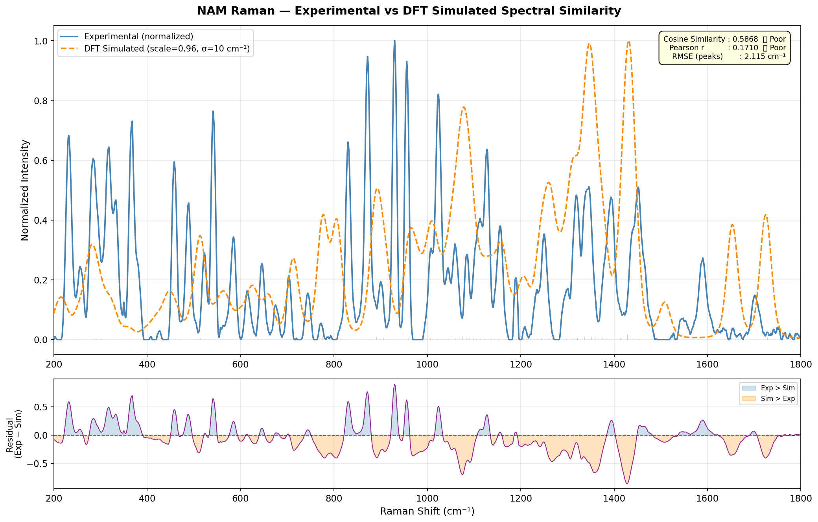
Figure 1. Normalised experimental NAM spectrum overlaid with the broadened DFT simulation and residual trace.
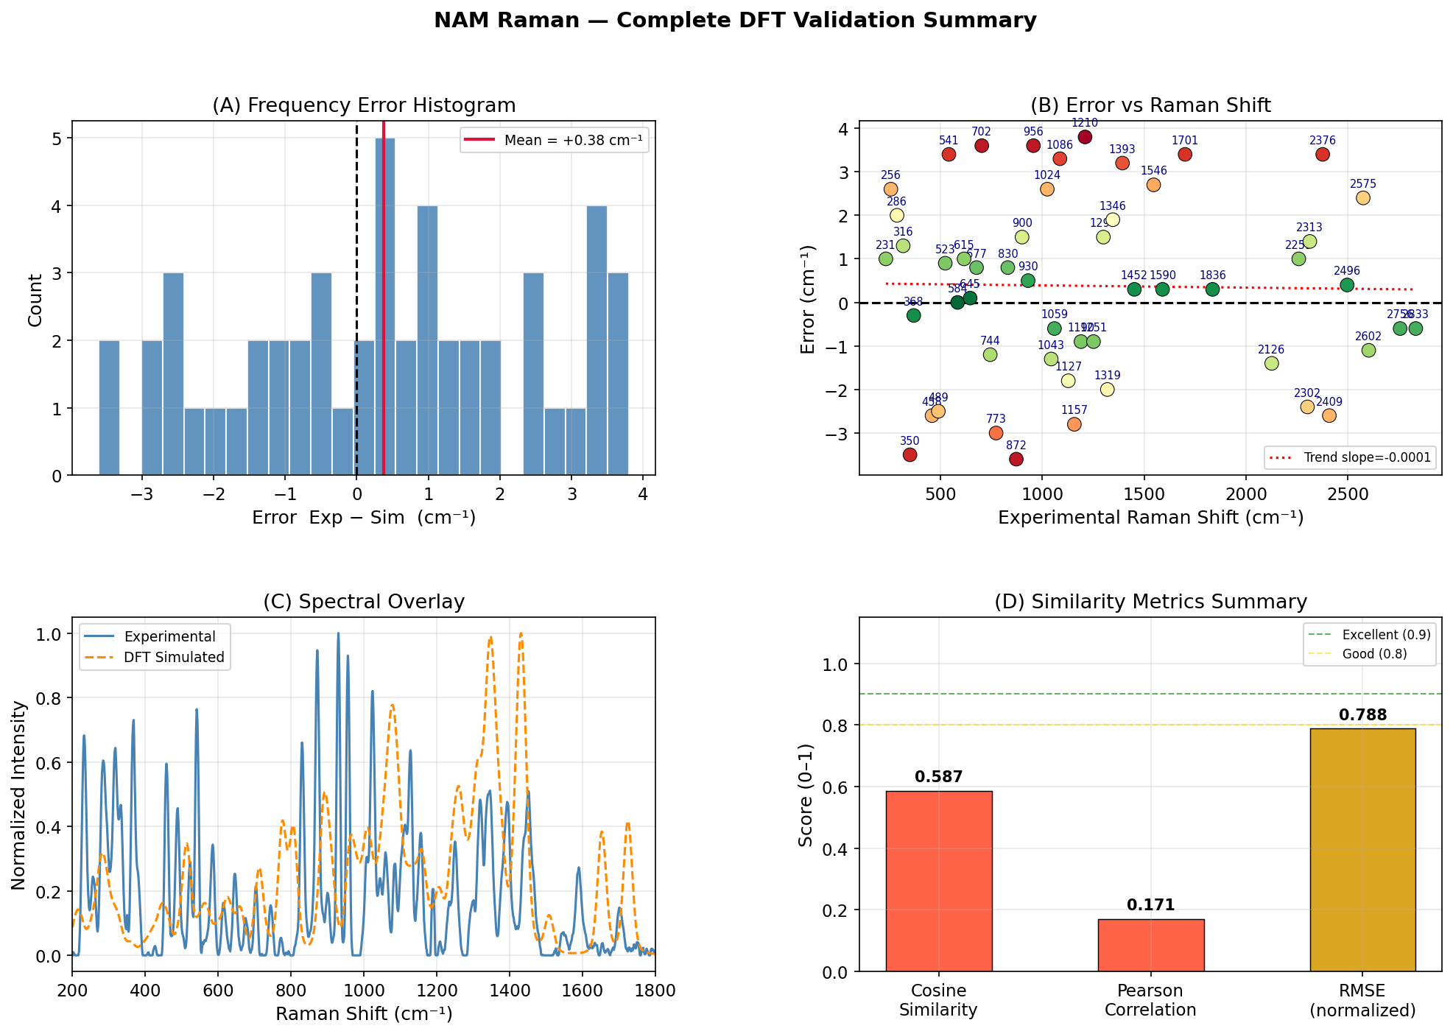
Figure 2. NAM validation summary: peak-error distribution and experimental / DFT comparison panels.

6.2 LTA — experimental reproducibility and fragment interpretation
LTA was investigated in two complementary experimental branches.
Fixed-condition spatial-reproducibility study
Metric | Result
Design | 12 spatial spots on the powder sample, fixed at 20 s integration / 20% laser power
Characteristic peaks identified | 7
Average spot-to-spot spectral correlation | 0.9787
Average peak coefficient of variation (CV) | 16.74%
This indicates good spot-to-spot reproducibility and acceptable powder homogeneity under fixed acquisition conditions.
Expanded acquisition-parameter study
Metric | Result
Spectra ranked | 136 files across 10–25 s integration and 5–80% power
Best condition | 20 s / 40% power (file sec-20_power-40_i-2_2.xlsx)
Best-spectrum SNR | 139.03
FWHM (best spectrum) | 9.13 cm⁻¹
Composite quality score | 69.7490
Major experimental bands | ≈ 413, 619, 795, 1000, 1030, 1182, 1601 cm⁻¹ (phosphate/backbone, carbohydrate, CH₂ and amide-related regions)
Peak matching vs. DFT (7 selected peaks) | 7/7 matched; mean error 0.41 cm⁻¹; RMSE 2.70 cm⁻¹; maximum error 4.00 cm⁻¹
Full-spectrum shape similarity | Cosine similarity 0.2397; Pearson correlation −0.0084
As with NAM, selected-peak agreement with the DFT fragment library is good, but whole-spectrum shape similarity is weak — these are two different questions and both should be reported. A further, earlier analysis branch (20-04/lta/results/final_summary_report.txt) currently returns NaN fit weights and NaN fit metrics and should be re-run and verified before being cited as evidence; it is not included in the results above.
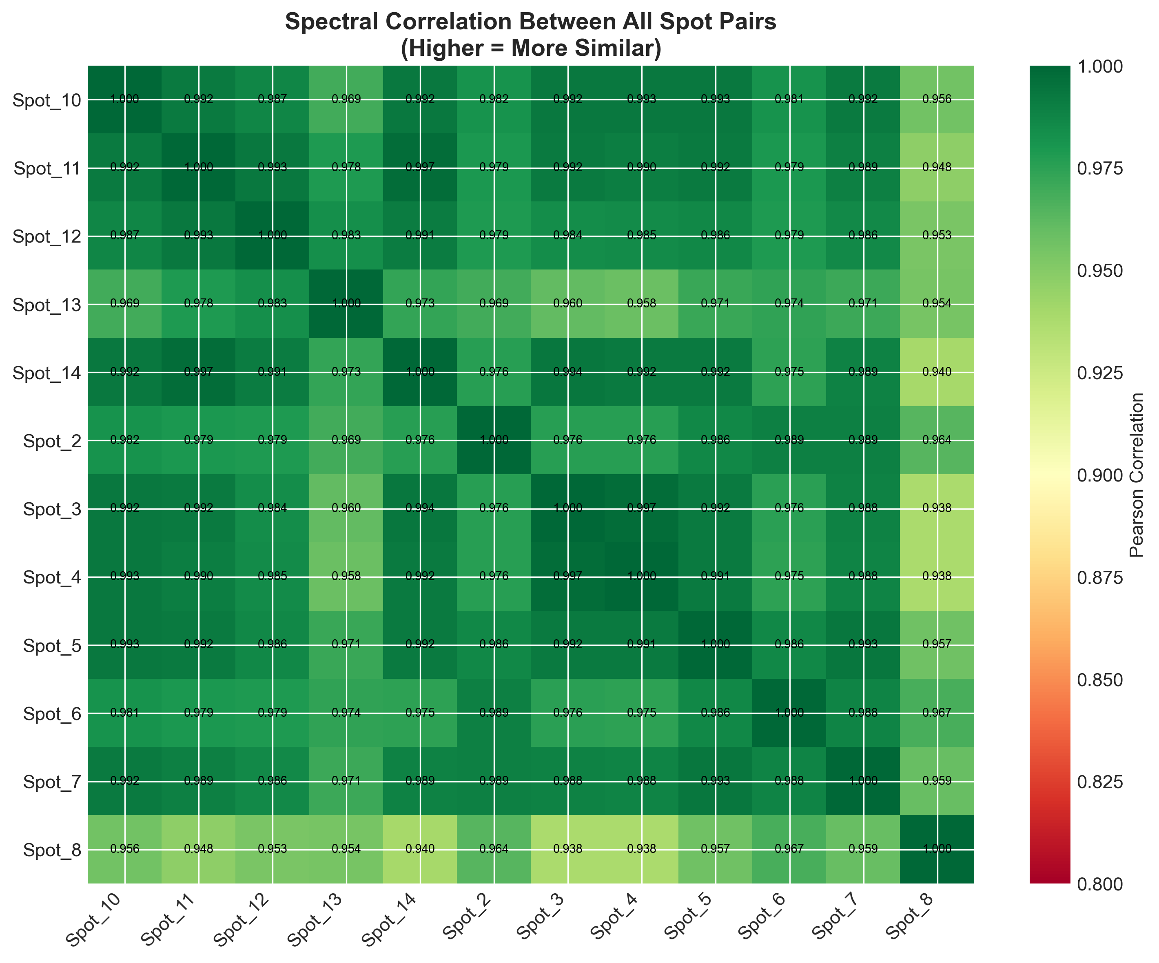
Figure 3. Spot-to-spot Pearson correlation matrix from the 12-spot fixed-condition LTA reproducibility study.
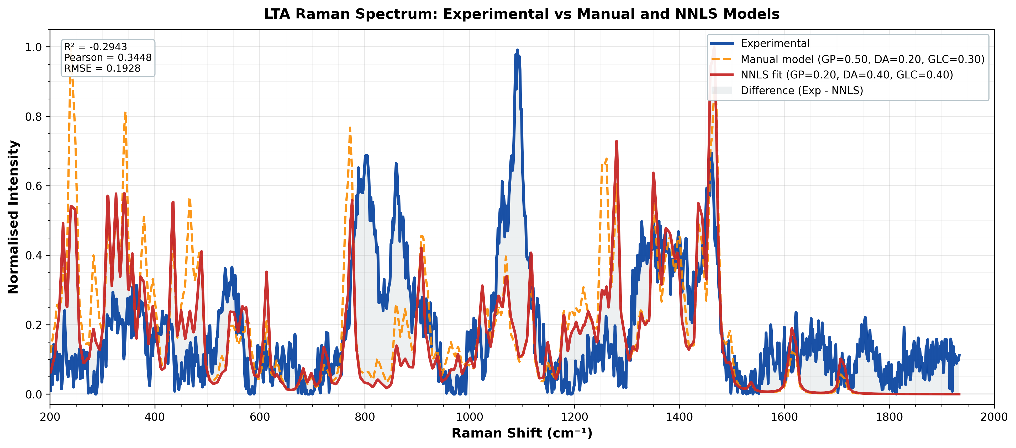
Figure 4. LTA experimental spectrum compared against the manual and NNLS fragment-based models.

6.3 LPS — fragment-based reconstruction and NNLS fitting
LPS was treated as a large, heterogeneous glycolipid for which intact-molecule quantum simulation is impractical. The final documented workflow used an experimental spectrum (sec-60_power-20_i-30 acquisition), with ALS baseline correction, Savitzky–Golay smoothing, min–max normalisation, interpolation onto a common 200–2000 cm⁻¹ grid, adaptive peak detection, and NNLS fitting of the five DFT fragment spectra against the experimental spectrum.
Metric | Result
NNLS fragment weights | KDO 47.3%; heptose 25.8%; glucosamine 15.3%; myristic acid 11.7%; phosphoric acid 0.0%
NNLS fit quality | RMSE 0.1850; R² 0.1799; Pearson r 0.5078
Equal-weight baseline (comparison) | RMSE 0.1885; R² 0.1488; Pearson r 0.4165
Improvement over equal-weight baseline | RMSE improved 1.8%; R² improved 21.0%
Peaks / residual mismatch | 25 experimental peaks detected; best-matched regions 707–779, 870–892 and 921–945 cm⁻¹; other regions remain identifiably mismatched
The LPS analysis pipeline is complete end-to-end and produces a chemically interpretable decomposition — KDO is the dominant fitted contributor — but the model explains only a limited proportion of global spectral variance (R² ≈ 0.18) and should be reported as a preliminary, interpretable reconstruction rather than a validated identity proof. This is the least mature of the three biomarker workstreams and is the priority for the next phase of Objective 1 work.

7. SERS Substrate Development
A key requirement of Objective 2 is a SERS-enabled nanosensor chip. A nanostructured/porous silicon substrate was fabricated using a wet-chemical route: hydrofluoric-acid (HF) etching of the silicon surface followed by AgNO₃-based galvanic displacement deposition of silver nanoparticles, producing an Ag-coated nanostructured silicon surface capable of electromagnetic Raman signal enhancement. This directly addresses Objective 2 — development and optimisation of a SERS-enabled nanosensor chip.

8. SERS Substrate Validation Using R6G
Before applying the fabricated substrate to bacterial biomarkers, Rhodamine 6G (R6G) — a molecule with a well-established Raman spectrum — was used as the positive-control probe to confirm that the Ag/Si substrate and the full measurement/preprocessing workflow were functioning correctly, independent of any weak biomarker signal.
Metric | Result
Dataset size | 99 spectra in the detailed validation branch (≈ 97 in an earlier June-report count — minor version discrepancy)
R6G peak matching accuracy | 84.58%; mean shift error +0.81 cm⁻¹; MAE 3.25 cm⁻¹; RMSE 3.67 cm⁻¹
Cosmic-ray / spike handling | 1,491 spikes removed; 99.72% signal retention; 33.57% noise reduction
Substrate reproducibility | Mean Pearson correlation 0.7754 across replicates; best single value 0.81 (below the 0.90 internal target)
Selected optimal condition | 6-minute analyte soaking, 10% laser power, 5 accumulations
Preprocessing pipeline applied | ALS baseline correction, Savitzky–Golay smoothing, cosmic-ray removal, normalisation, peak detection, PCA and SNR evaluation
R6G experimentation should be read as substrate/sensor validation, not as sepsis-biomarker evidence. The results confirm the fabricated Ag/Si substrate produces measurable, calibratable Raman enhancement and that the acquisition/preprocessing pipeline is functioning correctly, but that batch-to-batch reproducibility (0.775 average correlation) is not yet at the target level for a finished sensor.

9. Biomarker Detection Using the Fabricated SERS Substrate
Following R6G validation, the same Ag/Si substrate was used for a preliminary investigation of NAM detection (the LPS and LTA Raman/SERS investigations described in Section 6 were carried out primarily on pure powder without the plasmonic substrate; substrate-based testing to date has focused on NAM as the first candidate).
Metric | Result
NAM SERS response | Characteristic features detected, but mean SNR only 0.89
Interpretation | NAM is detectable on the current platform but not yet robustly or reproducibly enhanced — the signal is close to the noise floor rather than a strong, diagnostically usable SERS peak
The substrate and measurement workflow are functional (as shown by R6G), but the current Ag/Si morphology and/or NAM adsorption behaviour are not yet sufficient for reliable biomarker sensing. This is expected and normal at this stage of substrate development, and defines the immediate next engineering task under Objective 2.

10. Investigation of NAM Detection — Limiting Factors
NAM detection on the SERS substrate has been the central experimental challenge of the current phase. Although theoretical calculations and pure-powder Raman measurements provide well-characterised expected vibrational signatures (Section 6.1), direct observation of a strong, SERS-enhanced NAM signal has been difficult. Several contributing factors have been identified from the experimental record:
- Low intrinsic Raman scattering cross-section of NAM under the investigated conditions.
- Weak adsorption / interaction between NAM and the current silver nanostructured surface (no functionalisation or selective capture chemistry has yet been applied).
- Competition between analyte adsorption and other species at the SERS hotspot sites.
- Concentration-dependent reduction of observable Raman features at the concentrations tested.
- Substrate-related spectral background and residual reproducibility variation (mean correlation 0.775, below the 0.90 target — Section 8).
- Possible orientation-dependent enhancement of specific molecular vibrational modes at the metal surface.
- The fundamental difference between detecting a purified molecular standard and detecting the same structural component embedded within a complex, intact bacterial cell wall.
The current mean NAM SNR of 0.89 on the SERS substrate should therefore not be interpreted as evidence that NAM is absent or undetectable in principle — pure-powder Raman and DFT work (Section 6.1) show a clear, validated NAM fingerprint exists. Rather, these experiments identify the specific limitations of the present substrate generation and point directly to the optimisation steps needed: increased and better-controlled Ag nanoparticle density, multiple deposition cycles, Ag–Au hybrid substrates, improved surface morphology, a selective capture/functionalisation layer for NAM, and systematic concentration-dependent studies.

11. Spectral Data Processing and Analysis Pipeline
A standardised, reusable analysis workflow was developed and applied consistently across NAM, LTA, LPS and R6G datasets:
- Raw Raman spectral acquisition and metadata parsing (integration time, laser power, replicate/spot identity encoded in file naming).
- Dark subtraction where applicable, using dark-subtracted intensity as the primary signal channel.
- Baseline correction using the Asymmetric Least Squares (ALS) method to remove fluorescence slope and drifting background.
- Savitzky–Golay smoothing to reduce high-frequency detector noise while preserving peak shape.
- Cosmic-ray / spike detection and correction (substrate-validation pipeline).
- Normalisation (vector, area, min–max, or activity-based, depending on the analysis objective).
- Automated peak detection using prominence, width and spacing criteria.
- Quality scoring using SNR, peak intensity, FWHM, sharpness, baseline quality and a composite score.
- Comparison against DFT reference spectra: peak matching, mean/RMSE frequency error, cosine similarity, Pearson correlation.
- Export of processed spectra, ranked tables, peak-matching tables, model metrics, residuals and publication-ready figures.

This dataset and pipeline are the structured foundation Objective 3 (AI-integrated Raman analysis) will require: 920 CSV and 462 XLSX spectral files, 40 Python scripts and 24 analysis notebooks are already organised for this purpose, though no classifier has yet been trained.

12. Current Status Against the Proposed Phases
Phase | Status | Evidence-based assessment
Phase 1 — Biomarker Identification through Pure Standards | Substantially addressed, ongoing | NAM and LTA have completed experimental + DFT reference workflows with quantified peak-matching. LPS has a complete analysis pipeline but a modest global fit (R² ≈ 0.18) and should be treated as a preliminary model. A first-generation Ag/Si SERS substrate has been fabricated and validated with R6G; NAM substrate testing is preliminary.
Phase 2 — Validation on Cultured Clinical Isolates | Not yet started | No cultured bacterial isolate data is present in the archive; this is the next stage after biomarker-level signatures are finalised and the substrate is optimised.
Phase 3 — Clinical Validation Studies | Not yet started (planning only) | A sepsis clinical biobank proposal, a sample biobank roadmap/SOP, and a technical SOP for blood collection, processing and storage have been drafted, but no patient samples have been collected or analysed.
Phase 4 — AI-Enabled SERS Biosensor Development | Foundation established; classification pending | A large, organised, quality-scored spectral dataset and reusable preprocessing pipeline exist (Section 11) and some exploratory PCA/ML code is present, but no trained, validated classifier or reported sensitivity/specificity exists yet.
Phase 5 — Point-of-Care Prototype Development | Future stage | The SERS sensing component (Sections 7–9) is the only prototype-relevant subsystem developed so far; no reader hardware, cartridge design or usability study has been undertaken.

13. Deliverable-Based Assessment
Deliverable | Status | Assessment
1. Structured Raman spectral library | In progress | Reference Raman + DFT datasets exist for NAM (81 spectra, 51 matched peaks) and LTA (12-spot + 136-spectrum studies, 7 matched peaks); LPS is represented by a 5-fragment computational library with NNLS composite fitting. Expansion to more biomarkers and to whole bacterial isolates is required for the full deliverable.
2. Optimised SERS chip | In progress | An Ag-coated nanostructured silicon substrate has been fabricated and validated with R6G (84.58% peak-matching accuracy, 0.775 mean reproducibility). Preliminary NAM testing (mean SNR 0.89) shows the chip is functional but not yet optimised for weak bacterial biomarkers.
3. AI-based Raman analysis algorithm | Preparatory stage | The processed, quality-scored dataset and preprocessing pipeline (Section 11) provide the data foundation; no trained classification algorithm has been completed.
4. Point-of-care prototype | Future stage | Not yet started; depends on completion of Deliverables 1–3 and clinical validation (Phase 3).

14. Overall Progress — Major Achievements to Date
- Selection and biological justification of NAM, LTA and LPS as a Gram-differentiating bacterial biomarker panel.
- Full computational (DFT) reference-spectrum generation for NAM (whole-molecule) and fragment-based models for LTA and LPS.
- Experimental Raman characterisation of NAM (81 spectra) and LTA (12-spot reproducibility study plus a 136-spectrum parameter study), each with quantified SNR-based acquisition optimisation.
- Quantitative experiment-vs-DFT validation: 51 matched NAM peaks (RMSE 2.115 cm⁻¹) and 7 matched LTA peaks (RMSE 2.70 cm⁻¹).
- NNLS-based fragment reconstruction of the LPS spectrum (R² 0.18, a 21% improvement over an equal-weight baseline).
- Fabrication of an Ag-coated nanostructured silicon SERS substrate by HF etching and AgNO₃ galvanic silver deposition.
- Validation of the SERS substrate using R6G (84.58% peak matching, 0.775 mean reproducibility).
- Preliminary SERS-based investigation of NAM on the fabricated substrate, with the limiting factors documented.
- Development of a standardised, reusable spectral preprocessing and quality-scoring pipeline applied across all four datasets.
- Preparation of clinical-translation planning documents: sepsis biobank proposal, biobank SOP/roadmap, and blood-sample collection/storage SOP, ready for use once ethical approvals are obtained.

15. Current Limitations
The most significant scientific limitation is that biomarker-level detection using purified powders and standard controls does not by itself establish performance in whole bacterial cells or clinical samples; the current work is a biomarker-and-sensor development stage, not a validated clinical diagnostic system. In addition, several data-quality and process issues in the archive should be resolved before the next phase:
- The archive contains multiple iterative report and analysis versions (e.g. two NAM DFT generations — Gaussian 09/B3LYP/6-311+G(d,p) vs. Gaussian 16 with a different basis set); one authoritative protocol should be selected and stated consistently.
- Laser power is recorded inconsistently as percent in some branches and as watts in others; the final methods description should fix the instrument-calibrated unit and preserve raw metadata.
- NAM and LTA show strong selected-peak agreement with DFT but weak whole-spectrum shape similarity (cosine/Pearson metrics); both should be reported together rather than only the stronger metric.
- One LTA analysis branch (20-04/lta/results/final_summary_report.txt) currently returns NaN fit weights/metrics and must be re-run and verified before being cited.
- SERS substrate reproducibility (mean correlation 0.775) is below the internal 0.90 target, and NAM SNR on the substrate (0.89) is not yet sufficient for a robust biomarker-sensing claim.
- The LPS NNLS model explains only a limited proportion of global spectral variance (R² ≈ 0.18) and should be treated as an interpretable preliminary model, not a final classifier.
- No concentration-response, limit-of-detection, replicate-batch, or clinical-matrix interference data yet exists for any of the three biomarkers.

16. Proposed Next Stage of Work
The next stage follows directly from the phase sequence defined in the original proposal, informed by the specific gaps identified above.
- Stage 1 — Freeze and standardise the evidence base: select one authoritative dataset and DFT protocol per biomarker, fix units, and archive superseded analysis branches.
- Stage 2 — Optimise the Ag/Si SERS substrate for NAM: increase and control Ag nanoparticle coverage, test multiple deposition cycles and Ag–Au hybrids, and improve surface morphology/adsorption.
- Stage 3 — Generate concentration-response evidence: serial dilution studies for NAM, LTA and LPS with blanks and replicates, reporting LOD, LOQ, linearity and precision.
- Stage 4 — Strengthen reproducibility: multiple substrate batches, multiple spatial spots, independent preparation days, targeting the 0.90 correlation threshold.
- Stage 5 — Finalise LTA and LPS models: re-run the NaN LTA branch, add realistic LPS fragment variants/conformers, and report residuals with uncertainty.
- Stage 6 — Bacterial isolate validation (Phase 2 of the proposal): compare biomarker-level Raman/SERS signatures against spectra from whole cultured bacterial isolates.
- Stage 7 — Begin approved clinical validation (Phase 3): activate the prepared biobank proposal and SOPs after ethical approval, and build a clinically annotated sample set.
- Stage 8 — AI development (Phase 4): use the curated, quality-scored spectral dataset to train and externally validate a classification model (e.g. PCA, SVM or Random Forest) with strict train/test separation.
- Stage 9 — Prototype development (Phase 5): integrate the optimised SERS sensor, Raman acquisition and AI-based interpretation into a portable point-of-care platform.

17. Conclusion
The present work represents the foundational biomarker-and-SERS-sensor development stage of the proposed intelligent sepsis detection project, and is aligned primarily with proposal Objectives 1 (biomarker discovery) and 2 (SERS-based sensing technology). Computational (DFT) and experimental Raman investigations of NAM, LTA and LPS have produced quantitatively validated reference spectral information — most strongly for NAM (51 matched peaks, RMSE 2.115 cm⁻¹) and LTA (7 matched peaks, RMSE 2.70 cm⁻¹), with LPS established as a working but preliminary fragment-based model (R² ≈ 0.18).
An Ag-coated nanostructured silicon SERS substrate has been fabricated and validated using R6G (84.58% peak-matching accuracy), confirming the sensing platform and analysis pipeline are functional. Subsequent preliminary NAM testing on this substrate (mean SNR 0.89) has demonstrated the practical challenges of direct bacterial-biomarker SERS detection and has generated a specific, evidence-based optimisation roadmap rather than an open-ended one.
The current results should be viewed as an essential and substantially completed step toward the proposed final system, not as completion of the clinical diagnostic objective. The established biomarker spectra, DFT models, fabricated SERS substrate, validated analysis pipeline, and prepared clinical-translation documents (biobank proposal and SOPs) together provide the basis for the next phase: substrate optimisation, concentration-response characterisation, bacterial-isolate validation, AI-assisted classification, clinical validation and, ultimately, point-of-care prototype development — consistent with the five-phase pathway defined in the original project proposal.

Appendix A — Key Quantitative Results Summary
Area | Key Values
NAM (pure powder Raman + DFT) | 81 spectra; best condition 25 s / 80% power; SNR 95.91; 51 matched peaks; RMSE 2.115 cm⁻¹ (mean +0.378, SD 2.102, max 3.8 cm⁻¹); cosine similarity 0.5868; Pearson 0.1710.
LTA — spatial reproducibility | 12 spots, 20 s / 20% power; 7 characteristic peaks; average correlation 0.9787; average peak CV 16.74%.
LTA — expanded acquisition study | 136 spectra; best condition 20 s / 40% power; SNR 139.03; FWHM 9.13 cm⁻¹; 7/7 peaks matched vs. DFT, RMSE 2.70 cm⁻¹; global cosine 0.2397, Pearson −0.0084.
LPS — NNLS fragment fitting | Weights: KDO 47.3%, heptose 25.8%, glucosamine 15.3%, myristic acid 11.7%, phosphoric acid 0.0%; RMSE 0.1850; R² 0.1799; Pearson r 0.5078 (21% R² improvement over equal-weight baseline).
R6G — SERS substrate validation | 99 spectra; 84.58% peak-matching accuracy; RMSE 3.67 cm⁻¹; mean reproducibility correlation 0.7754 (target 0.90); optimal condition: 6 min soak, 10% power, 5 accumulations.
NAM on Ag/Si SERS substrate | Mean SNR 0.89 — features detected, enhancement not yet sufficient for a robust biomarker-sensing claim.

Appendix B — Supporting Documents and Evidence Reviewed
This deliverable was compiled from the full project archive. Principal source documents include:
Category | Representative Files
Governing proposal | Sepsis Detection using SERS Nanosensor_Proposal_2025 by sir.pdf
Prior full project report | sukesh-m24im1007-report.pdf / .docx (49-page submitted-style report); Final_Project_Report.docx; finalmtp.docx
Prior consolidated status report | Project_Status_Report_Sepsis_SERS_As_of_August_2026.pdf (evidence cutoff 3 Aug 2026)
NAM evidence | review meeting/NAM-EXP-P/NAM/*.ipynb (Raman analysis, validation, peak assignment); NAM_analysis_report.txt; NAM Papers.docx; nam spectra details.docx; NAM-documentation.docx
LTA evidence | review meeting/LTA - EXP/Pure Powder spectra/LTA_outputs/*; 20-04/20sec20power-variable location LTA/*; 20-04/lta/*; LTA Spectra.docx; Computational Simulation Settings Used for Lipoteichoic Acid.docx
LPS evidence | LPS analysis notebooks and output/plots; lps research folder
Substrate / R6G evidence | Development and Validation of a Silver.docx; Monthly Progress Report-June.docx; r6g-from-my-pc, dated substrate folders (13-08-2026-raw-si, 14-08-2026-sers-r6g-nam..., 14-08-26-lta-2m-etched)
Protocols and clinical-translation planning | Preparation of NAM Stock solution.docx; SERS Experiment phases.docx; Specific capture probe for NAM.docx; Professor-level Proposal_ Sepsis Clinical Biobank & Sers Diagnostic Platform.docx; Sepsis Sample Biobank Roadmap & Sop.docx; Technical Sop_ Blood Sample Collection.docx
Molecular modelling support | molecule building/*; python code/*; 3d-compound/*; N-ACETYL-BETA-MURAMIC ACID/*
Presentations / review material | Project_Presentation_4th Sem.pptx; LPSLTA.pptx; nam-final.pptx; updated Review Meeting ppt.pptx

Interpretation note: where the archive contains duplicate or iterative versions of the same analysis, the most recent, most complete branch was used for the figures reported in this document, and unresolved branches (e.g. the NaN LTA fit) were explicitly excluded rather than silently averaged.

